**KS2 progress and attainment in reading, writing and maths**

EXS – expected standard 

GDS – greater depth standard

RWM – reading, writing and maths combined

**KS2 Reading progress KS2 Reading attainment**

|  |  |  |  |
| --- | --- | --- | --- |
| School EXS | National EXS | School GDS | National GDS |
| 64% | 73% | 18% | 29% |

***Below average -1.73***

Confidence interval

-3.4 to -0.1

**KS2 Writing progress KS2 Writing attainment**

|  |  |  |  |
| --- | --- | --- | --- |
| School EXS | National EXS | School GDS | National GDS |
| **61%** | 71% | 5% | 13% |

***Well below average -3.00***

Confidence interval

-4.6 to -1.4

**KS2 Maths progress KS2 Maths attainment**

|  |  |  |  |
| --- | --- | --- | --- |
| School EXS | National EXS | School GDS | National GDS |
| 54% | 73% | 29% | 24% |

***Average -1.61***

Confidence interval

-3.2 to 0.0

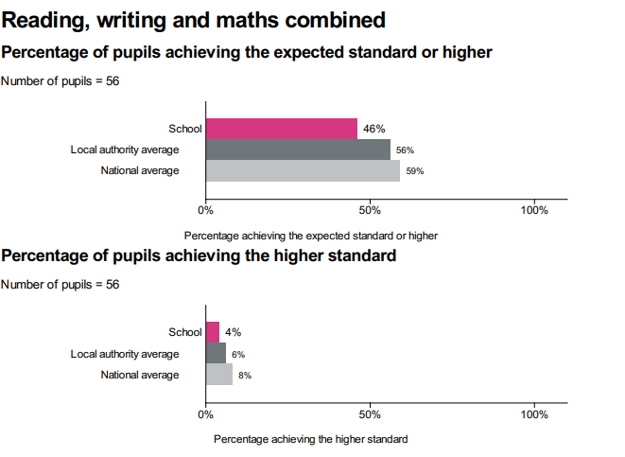

**KS1 attainment in reading, writing and maths**

|  |  |  |
| --- | --- | --- |
| KS1 | School EXS | School GDS |
| Reading | 63% | 23% |
| Writing | 46% | 0% |
| Maths | 60% | 9% |
| R/W/M  combined | 37% | 0% |